Inspection History Feature Overview

*Ensure internet access* - Inspection History requires the internet and/or cellular connection and can’t be accessed offline

Access

From the mobile app, choose the hamburger menu at the top left, then option ‘Inspection History’ at the far left.

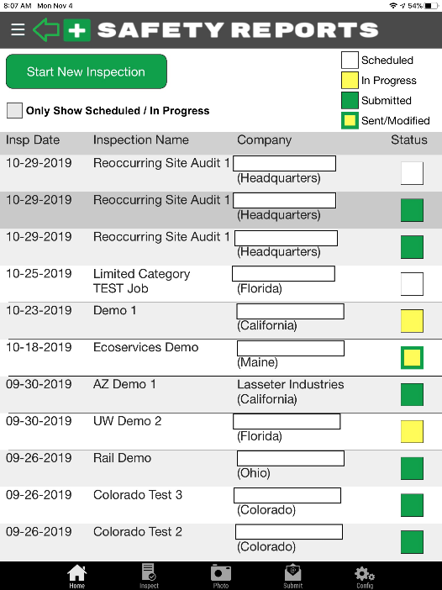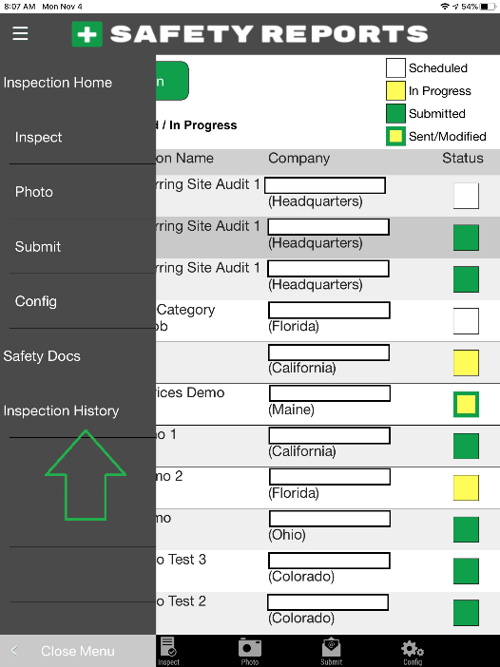

The last 20 jobs are shown in a new browser window by default, like the “Home” screen of the mobile app, shown here in Landscape orientation

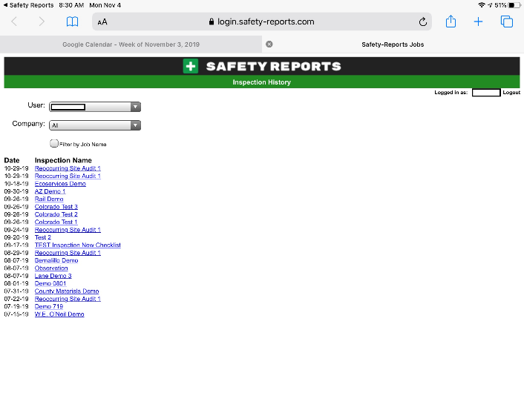

Filtering by Inspector  Open the ‘User’ dropdown to show the last 20 inspections by inspector, the checkmark denotes what is currently being displayed  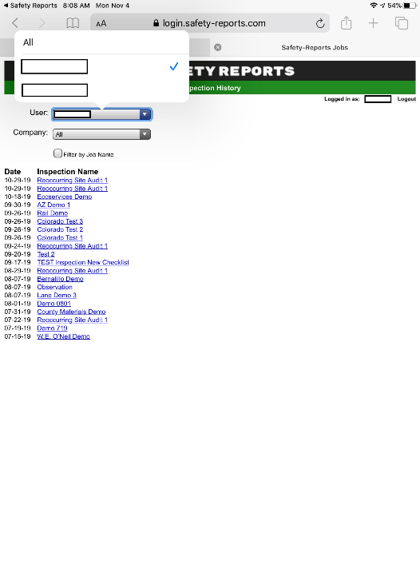 | Filtering by Company  Open the ‘Company’ dropdown to show the last 20 inspections by site/client/project etc. depending on account setup, the checkmark denotes what is currently being displayed  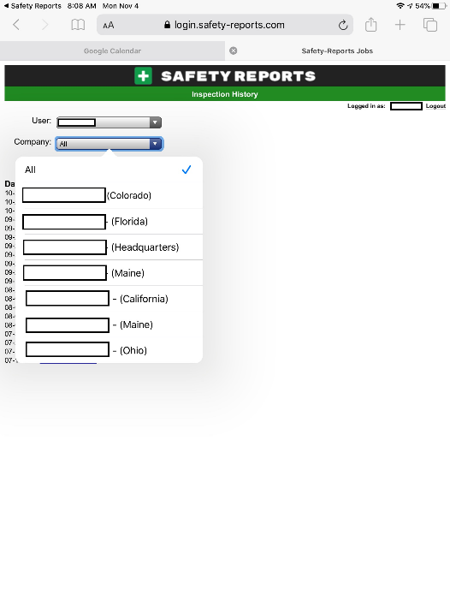
Filtering by Job
Check the box marked “Filter by Job Name” to enter the ID of a specific past job, and enter the job name in the text field which appears, then click “Go”
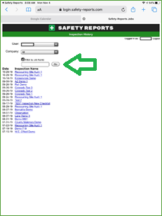

Questions?
Contact Support (402) 403-6575 option ‘2’ support@safety-reports.com

