|  |
| --- |
|  |

**Safety Docs Feature Overview**

**Access**

From the online administrator view: choose the ‘Safety Documents’ option at the far-left

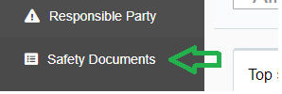

**Building, Naming, Modifying Folders**

|  |  |
| --- | --- |
| Click ‘Add New’ (blue link) above the column | Choose ‘folder’ then enter the name in the field, followed by ‘Add’ |
| Choose the ‘Edit’ option at the far-right. | |
| Enter the new name for the folder and choose ‘Update’ | |

**Modifying Content**

Choose the folder to modify: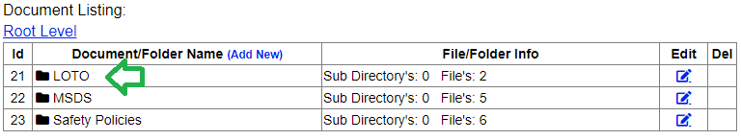

Delete or edit content using the functions at the far-right:

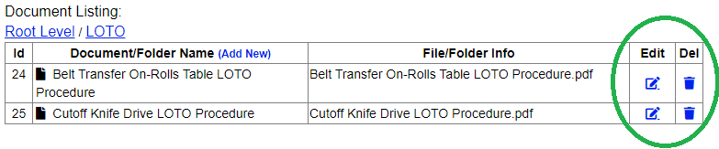

Changing display names, hiding or moving items and document previews are functions available in the ‘Edit’ screen.

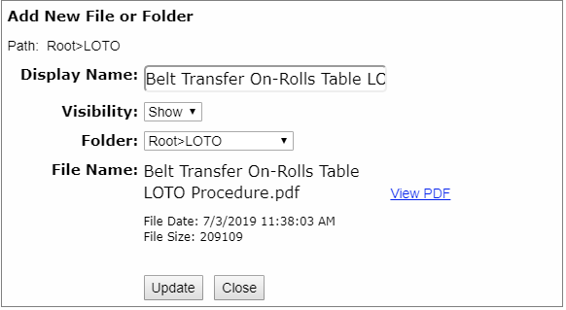

**Adding Content** (same process as new folders)

|  |  |
| --- | --- |
| Choose ‘File,’ then select | Upload the selected file, then close |